RESOLUTION NO.__________

RE: CERTIFICATE OF APPROPRIATENESS UNDER THE
PROVISIONS OF THE ACT OF THE PENNSYLVANIA
LEGISLATURE 1961, JUNE 13, P.L. 282 (53
SECTION 8004) AND BETHLEHEM ORDINANCE NO.
3952 AS AMENDED.

WHEREAS, it is proposed to replace the existing light box lens and install window signs at 306 Brodhead Ave.

NOW, THEREFORE, BE IT RESOLVED by the Council of the City of Bethlehem that a Certificate of Appropriateness is hereby granted for the work.

Sponsored by: (s)

(s)

ADOPTED BY COUNCIL THIS DAY OF

(s)
President of Council

ATTEST:

(s)
City Clerk

HISTORIC CONSERVATION COMMISSION

CASE # 458 – It is proposed to replace the existing light box lens and install window signs at 306 Brodhead Ave.
OWNER/APPLICANT: Mark Hoffman / Sign A Rama, Lehigh Valley

The Commission upon motion by Mr. Cornish seconded by Mr. Evans adopted the proposal that City Council issue a Certificate of Appropriateness for the proposed work described herein:

- The proposal to replace existing light-box lens and install window signs at 306 Brodhead Ave. was presented by Kevin McGee of Sign a Rama, Lehigh Valley.

- The existing light box lens (44” x 172”) will be removed and replaced with a new lens with vinyl graphics The light box sign will read “Hoffman Insurance Consultants, LLC, Business Insurance Health & Life Insurance; Myers & Bell Insurance Agency, Inc. Auto Home Business Health Life” “Parking in Rear”.

- The design of this sign will be altered to have the two business names and services side by side with “Parking in Rear” located below the business information. The center vertical line will be deleted.

- The business names will be navy, other lettering black on a white background with “Parking in Rear” in red.

- The proposed window signs will read the same and have 4” high white vinyl letters. The longest line will be 42” wide. The lettering will be white and the signs will be centered in the respective windows. One business name will be in each window.

- The business names will also be placed on the entry door in a stacked arrangement with 2” high white vinyl letters.

- A serif style font will be used for all the signs, as proposed, except for “Parking in Rear” which is a script style.

- All other signs in windows will be removed.

- The proposed motion was unanimously approved.

CU: cu

By: 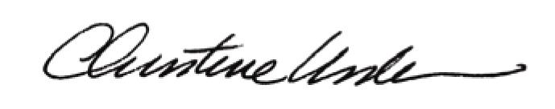

Date of Meeting: July 15, 2013 Title: Historic Officer

